Assigment No 4

1) Write a select command that produces the order
number, amount, and date for all rows in the Orders
table.

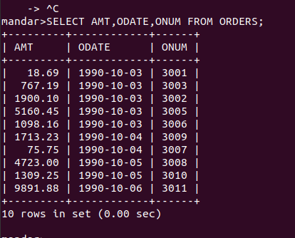

2) Write a query that produces all rows from the
Customers table for which the salesperson’s number
is 1001.

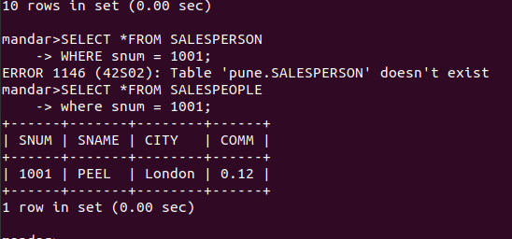

3) Write a query that displays the Salespeople
table with the columns in the following order:
city, sname, snum, comm.
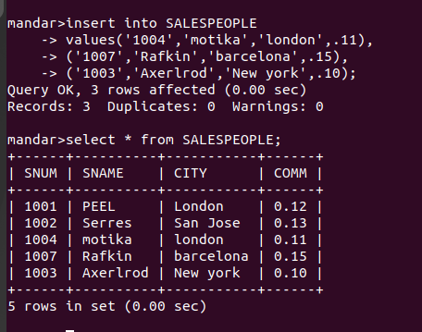

4) Write a select command that produces the rating
followed by the name of each customer in San Jose.

